Create bill:

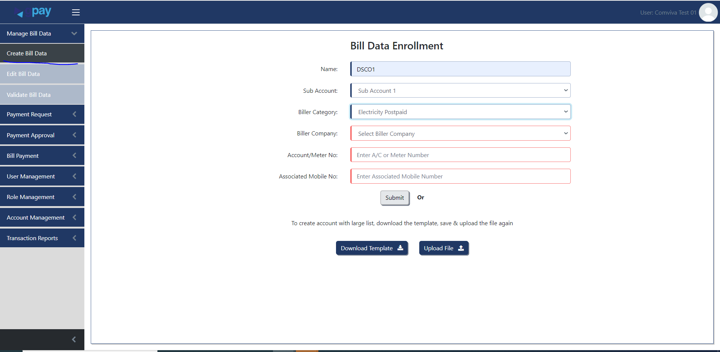

Validate bill; bill can be approved or rejected.

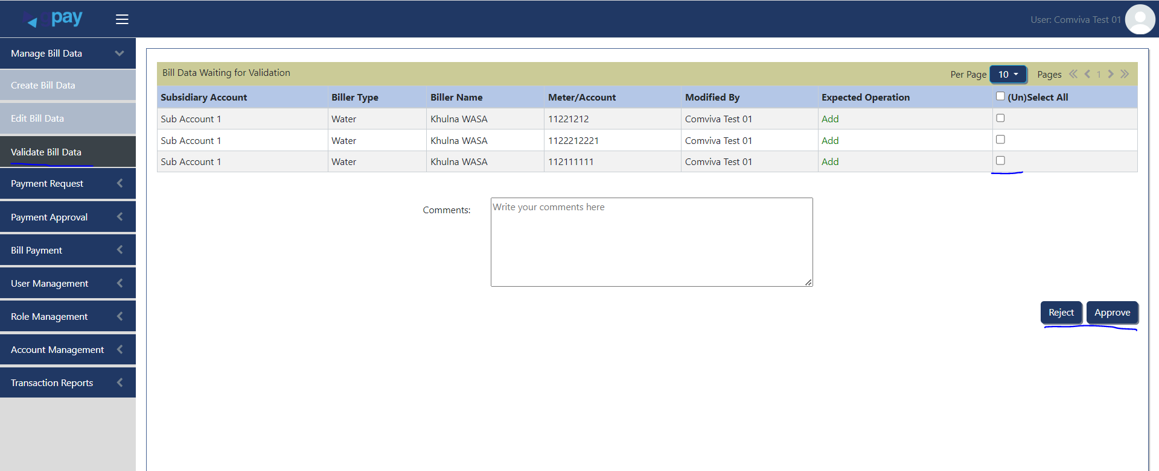

Approved bills are now ready to procces.

Refresh bill: Once you refresh, you can create a payment request and pay the bill accordingly.

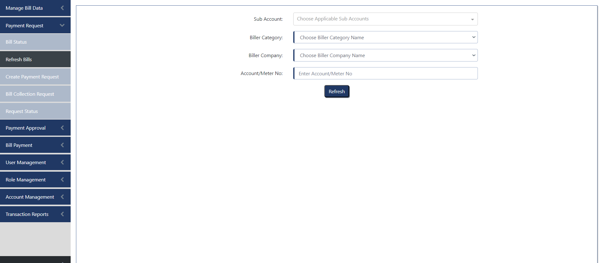

Bill no: 17021273:

Payment request:

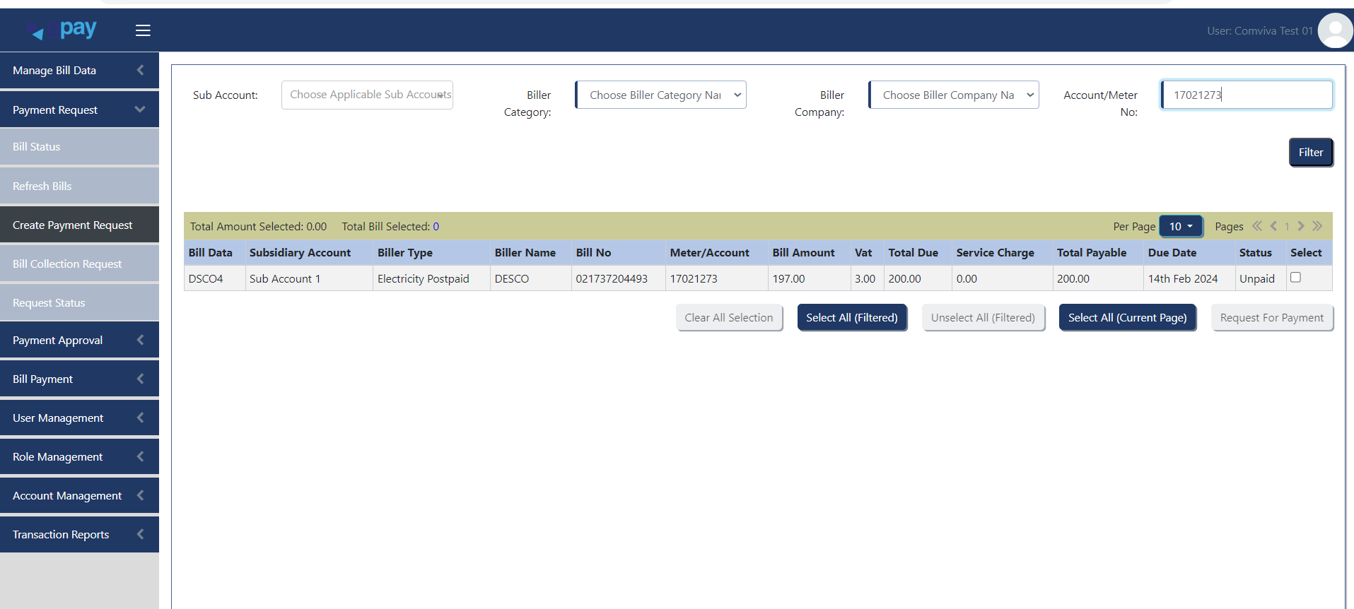

Approve payment:

Need to check the bill and approve for the payment.

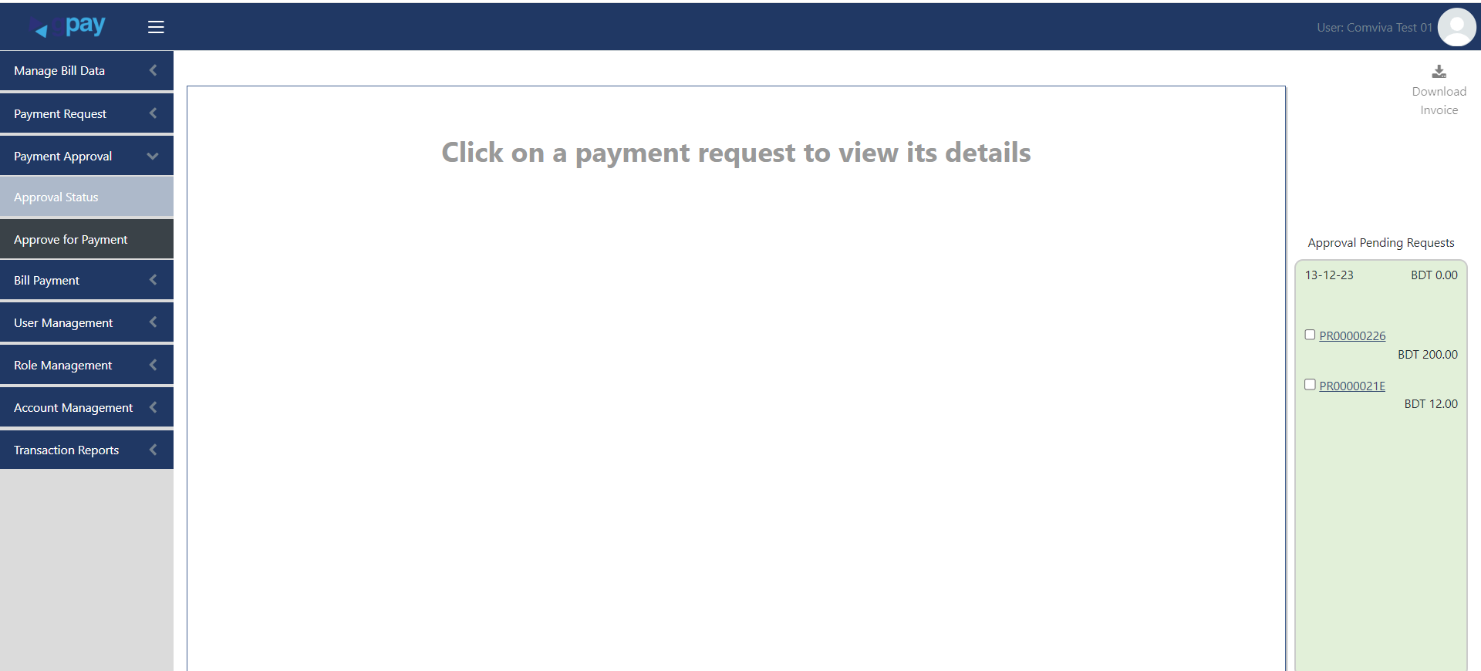

Write a command and approve the bill.

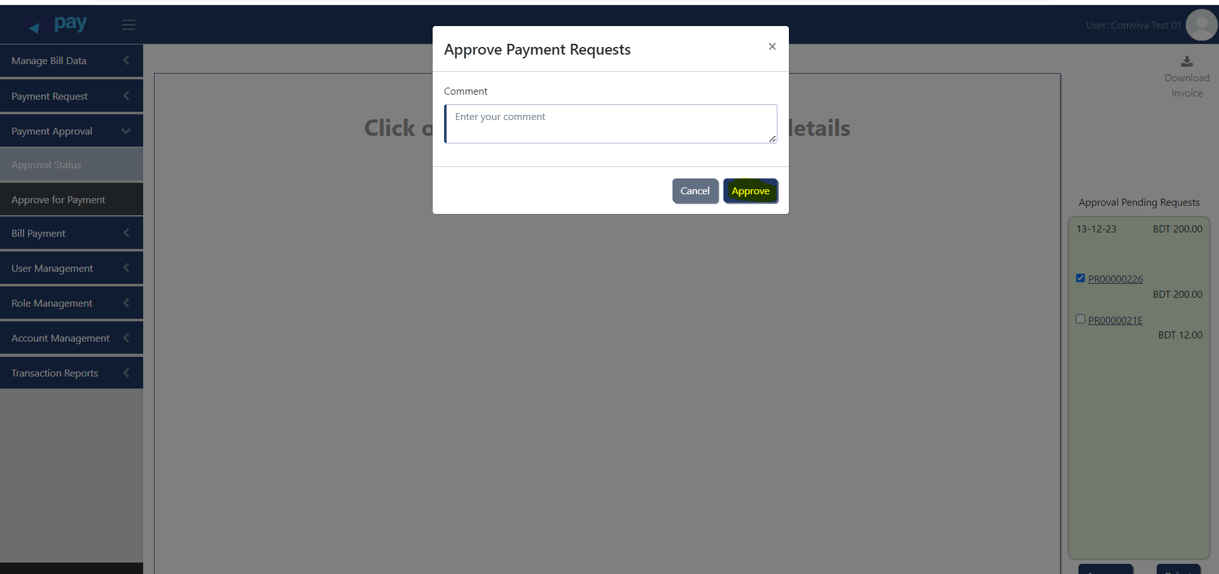

Bill is ready for payment once it has been approved.

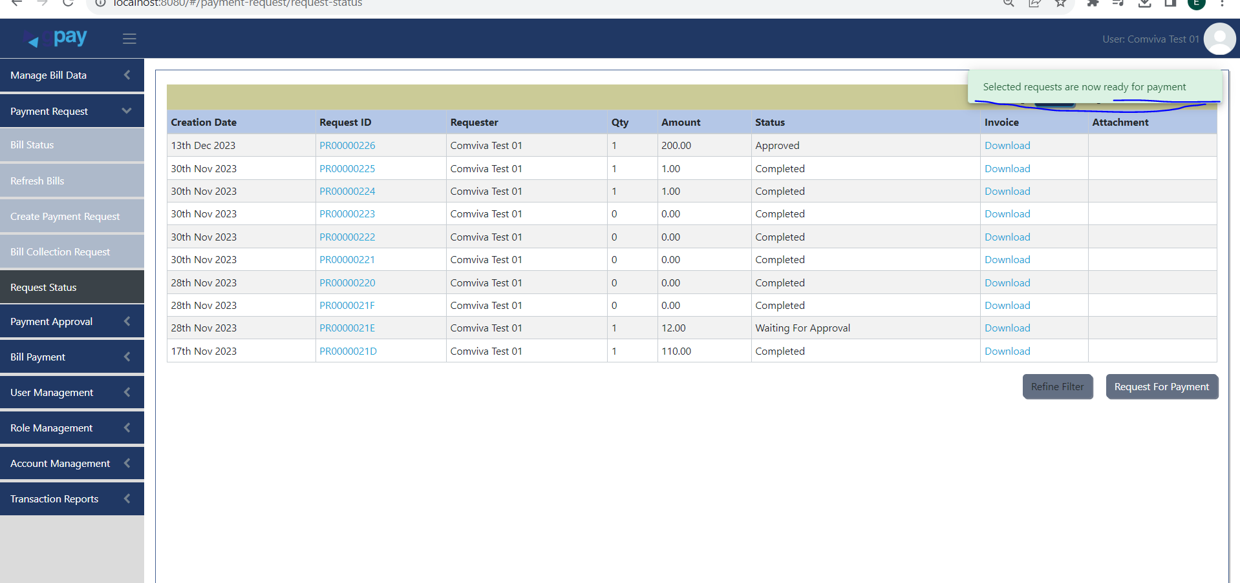

Approved bill will be present in bill payment tab, where user can pay the bill.

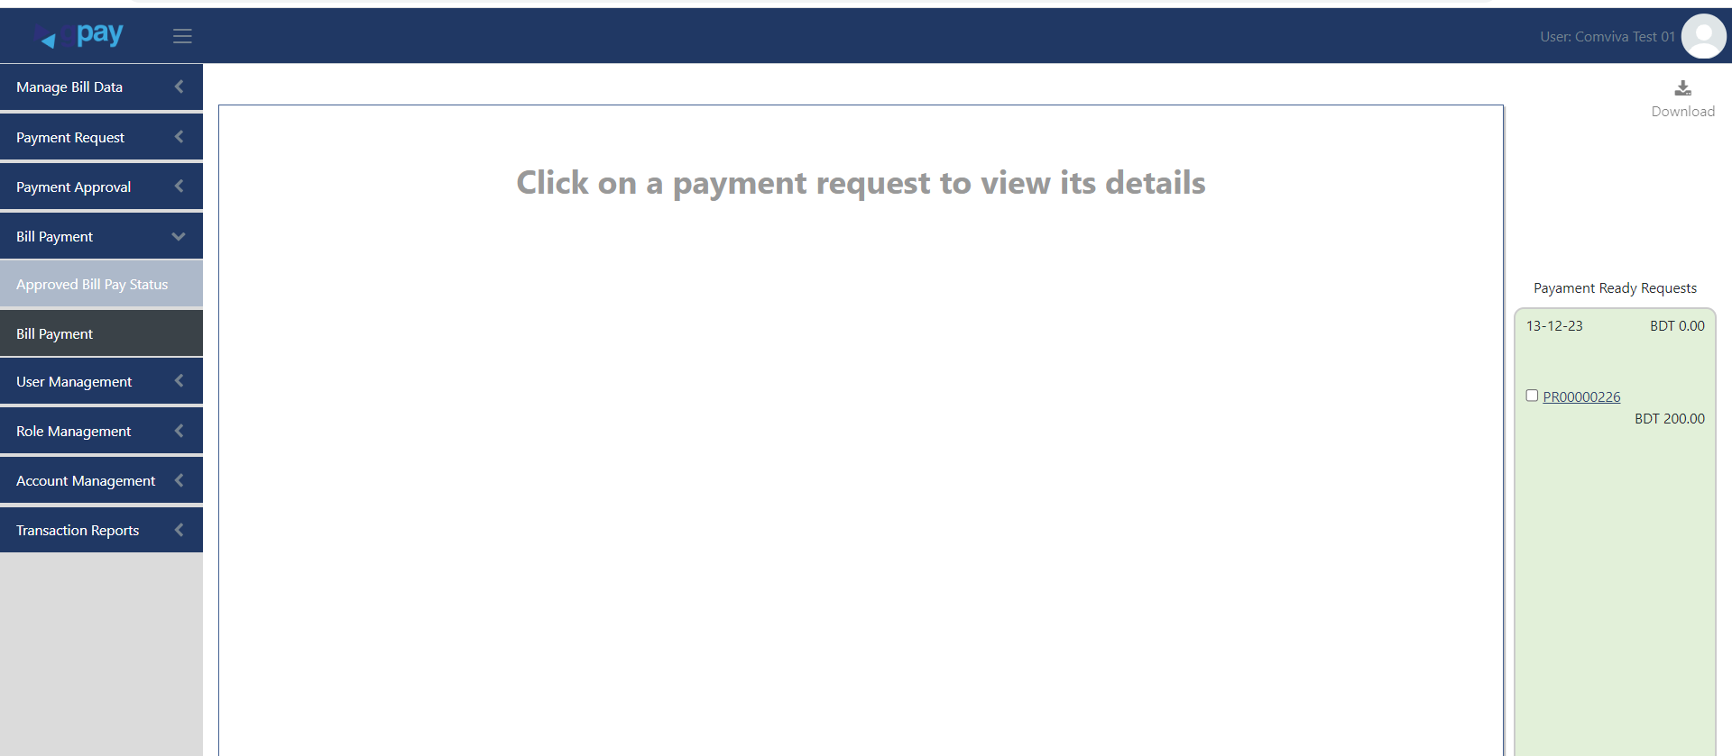

Select the bill and pay.

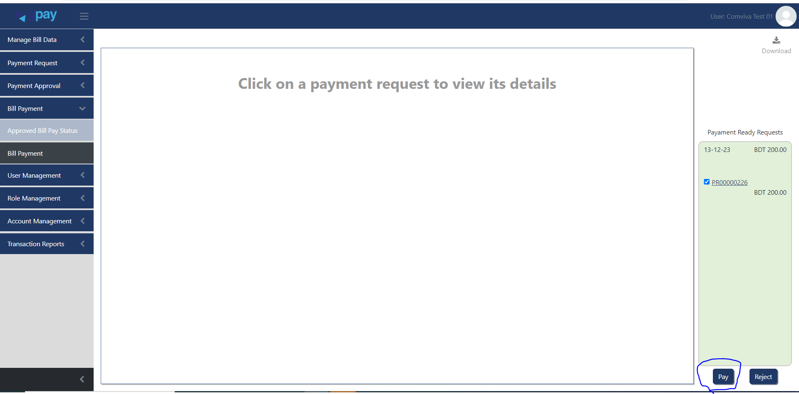

Payment.

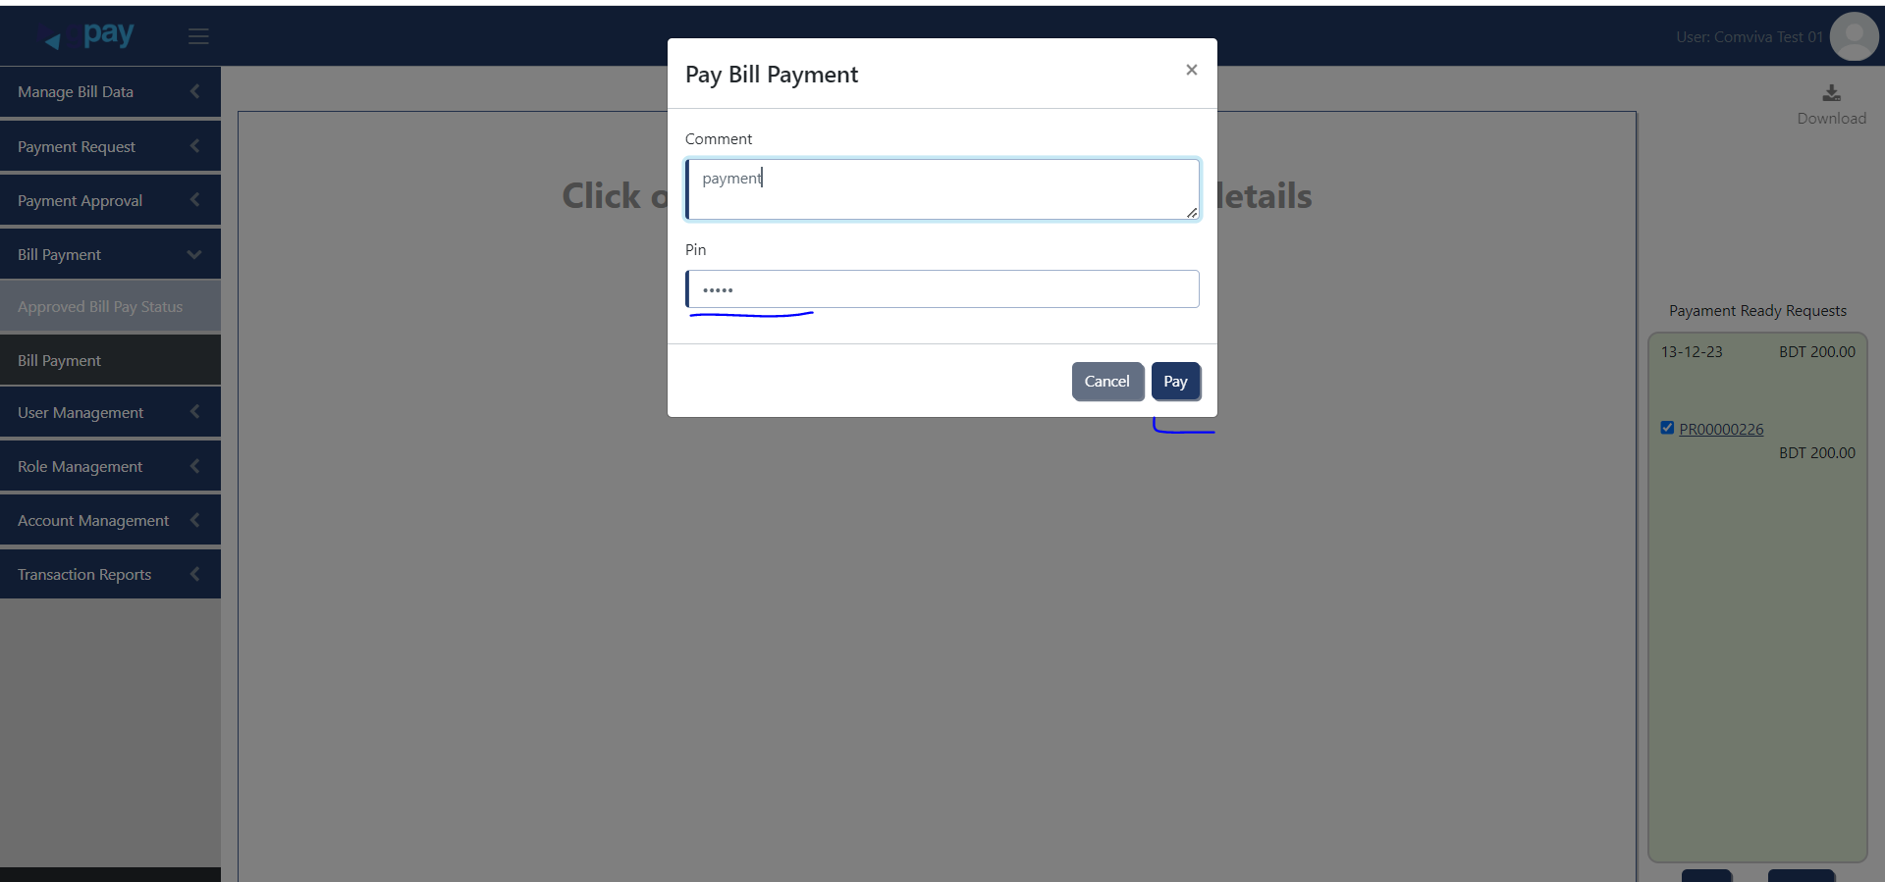

Invalid Pin:

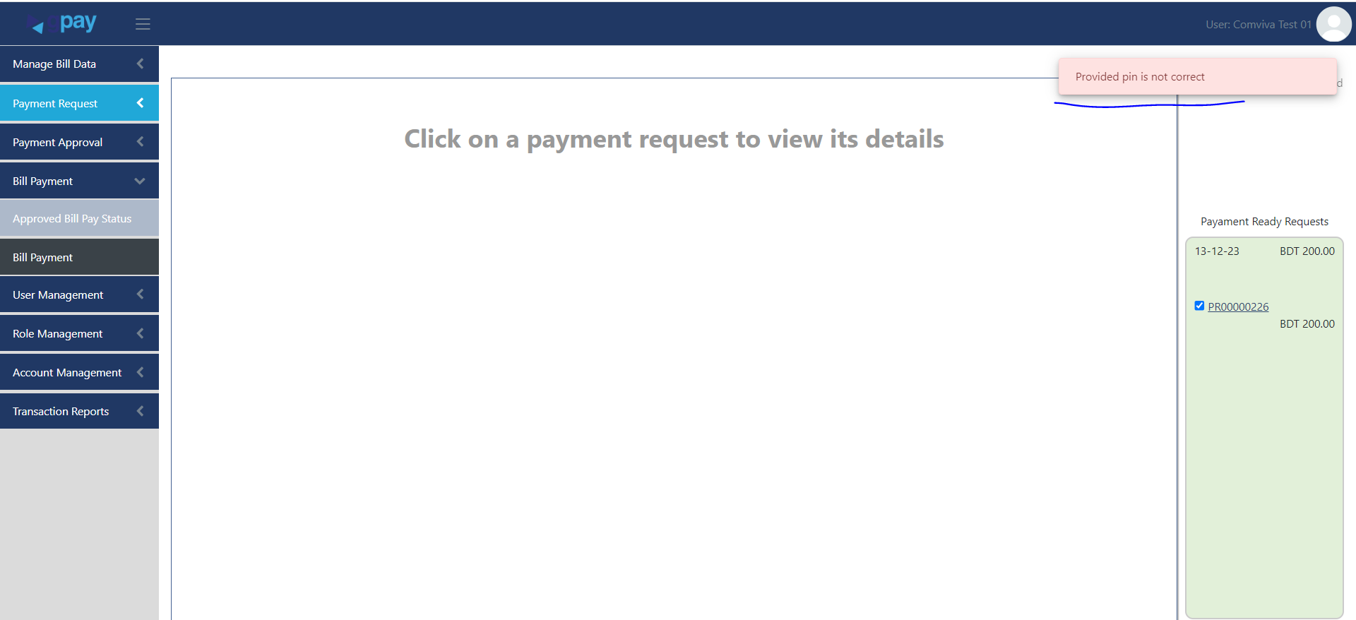

You can check the bill status based on the payment.

